rom[ 0] = 32'h00000137; // lui x2, 0x00001
rom[ 1] = 32'h00010113; // addi x2, x2, 0x000
rom[ 2] = 32'h20000293; // addi x5, x0, 0x200
rom[ 3] = 32'h30529073; // csrrw x0, 0x305, x5
rom[ 4] = 32'h000015b7; // lui x11, 0x00001000
rom[ 5] = 32'h3045a073; // csrrs x0, 0x304, x11
rom[ 6] = 32'h300023f3; // csrrs x7, 0x300, x0
rom[ 7] = 32'h0083e393; // ori x7, x7, 0x008
rom[ 8] = 32'h30039073; // csrrw x0, 0x300, x7
rom[ 9] = 32'h10004537; // lui x10, 0x10004000
rom[ 10] = 32'h00050513; // addi x10, x10, 0x000
rom[ 11] = 32'h7d000593; // addi x11, x0, 0x7d0
rom[ 12] = 32'h00b52223; // sw x11, 0x004(x10)
rom[ 13] = 32'h00300593; // addi x11, x0, 0x003
rom[ 14] = 32'h00b52023; // sw x11, 0x000(x10)
rom[ 15] = 32'h00000013; // nop
rom[ 16] = 32'h00000013; // nop
rom[ 17] = 32'h05000593; // addi x11, x0, 0x050
rom[ 18] = 32'h00b52a23; // sw x11, 0x014(x10)
rom[ 19] = 32'h0a500613; // addi x12, x0, 0x0a5
rom[ 20] = 32'h00c52423; // sw x12, 0x008(x10)
rom[ 21] = 32'h00500593; // addi x11, x0, 0x005
rom[ 22] = 32'h00b52023; // sw x11, 0x000(x10)
rom[ 23] = 32'h00402783; // lw x15, 0x004(x0)
rom[ 24] = 32'hfe078ee3; // beq x15, x0, main_loop
rom[ 25] = 32'h00000013; // nop
rom[ 26] = 32'h00000013; // nop
rom[ 27] = 32'h01002583; // lw x11, 0x010(x0)
rom[ 28] = 32'h0085f593; // andi x11, x11, 0x008
rom[ 29] = 32'h00100513; // addi x10, x0, 0x001
rom[ 30] = 32'h00058863; // beq x11, x0, success
rom[ 31] = 32'h00000013; // nop
rom[ 32] = 32'h00000013; // nop
rom[ 33] = 32'h00000513; // addi x10, x0, 0x000
rom[ 34] = 32'h00a02423; // sw x10, 0x008(x0) //success
rom[ 35] = 32'h0000006f; // jal x0, end_loop
rom[ 36] = 32'h00000013; // nop
rom[ 37] = 32'h00000013; // nop

rom[ 128] = 32'hfc010113; // addi sp, sp, -64
rom[ 129] = 32'h00112023; // sw ra, 0(sp)
rom[ 130] = 32'h00a12223; // sw x10, 4(sp)
rom[ 131] = 32'h00b12423; // sw x11, 8(sp)
rom[ 132] = 32'h00c12623; // sw x12, 12(sp)
rom[ 133] = 32'h00d12823; // sw x13, 16(sp)
rom[ 134] = 32'h00e12a23; // sw x14, 20(sp)
rom[ 135] = 32'h34202573; // csrrs x10, 0x342, x0
rom[ 136] = 32'h00054c63; // blt x10, x0, check_intr
rom[ 137] = 32'h00000013; // nop
rom[ 138] = 32'h00000013; // nop
rom[ 139] = 32'h0600006f; // jal x0, isr_exit
rom[ 140] = 32'h00000013; // nop
rom[ 141] = 32'h00000013; // nop
rom[ 142] = 32'h7ff57593; // andi x11, x10, 0x7ff
rom[ 143] = 32'h00b00613; // addi x12, x0, 11
rom[ 144] = 32'h04c59663; // bne x11, x12, isr_exit
rom[ 145] = 32'h00000013; // nop
rom[ 146] = 32'h00000013; // nop
rom[ 147] = 32'h100046b7; // lui x13, 0x10004000
rom[ 148] = 32'h00068693; // addi x13, x13, 0x000
rom[ 149] = 32'h0106a783; // lw x15, 0x010(x13)
rom[ 150] = 32'h00300713; // addi x14, x0, 0x003
rom[ 151] = 32'h00e6ac23; // sw x14, 0x018(x13)
rom[ 152] = 32'h0087f793; // andi x15, x15, 0x008
rom[ 153] = 32'h02078063; // beq x15, x0, i2c_success
rom[ 154] = 32'h00000013; // nop
rom[ 155] = 32'h00000013; // nop
rom[ 156] = 32'h00000793; // addi x15, x0, 0x000
rom[ 157] = 32'h00f02223; // sw x15, 0x0004(x0)
rom[ 158] = 32'h0100006f; // jal x0, set_flag
rom[ 159] = 32'h00000013; // nop
rom[ 160] = 32'h00000013; // nop
rom[ 161] = 32'h00100793; // addi x15, x0, 0x001
rom[ 162] = 32'h00f02223; // sw x15, 0x004(x0)
rom[ 163] = 32'h00012083; // lw ra, 0(sp)
rom[ 164] = 32'h00412503; // lw x10, 4(sp)
rom[ 165] = 32'h00812583; // lw x11, 8(sp)
rom[ 166] = 32'h00c12603; // lw x12, 12(sp)
rom[ 167] = 32'h01012683; // lw x13, 16(sp)
rom[ 168] = 32'h01412703; // lw x14, 20(sp)
rom[ 169] = 32'h04010113; // addi sp, sp, 64
rom[ 170] = 32'h30200073; // mret

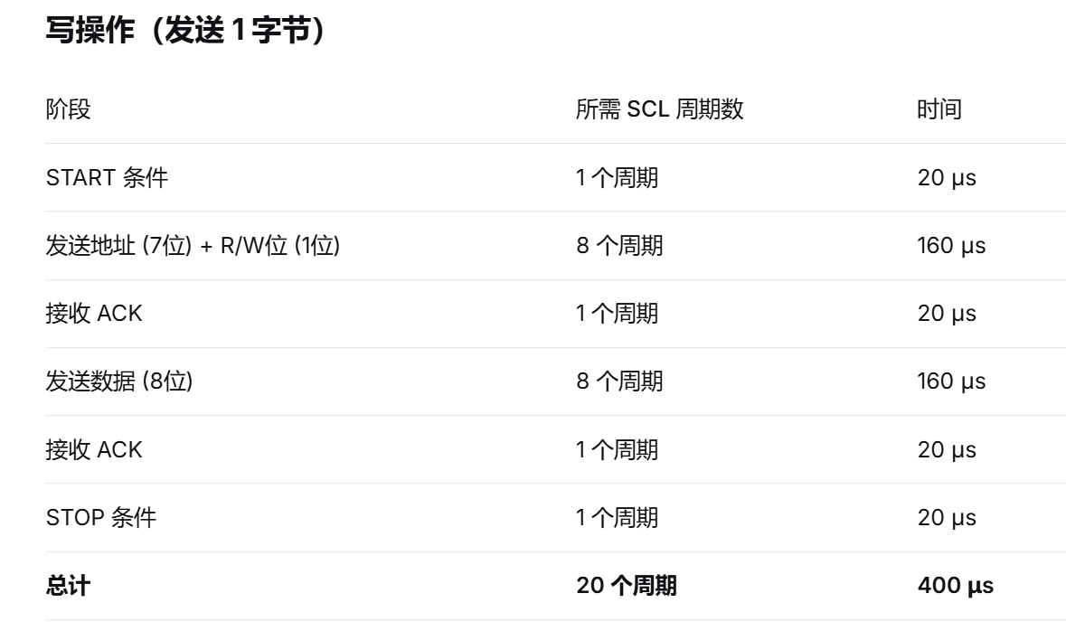
add wave -hex /tb_core_top/uut/if_pc
add wave /tb_core_top/uut/i2c_interrupt
add wave /tb_core_top/uut/interrupt_taken_pipe
add wave /tb_core_top/uut/u_i2c_master/i2c_state
add wave /tb_core_top/uut/u_i2c_master/scl_io
add wave /tb_core_top/uut/u_i2c_master/sda_io
add wave /tb_core_top/uut/u_i2c_master/ack_status
add wave -hex /tb_core_top/uut/mie
add wave -hex /tb_core_top/uut/mip
add wave -hex /tb_core_top/uut/u_data_ram/mem
add wave -position 0 sim:/tb_core_top/clk
add wave -position 1 sim:/tb_core_top/uut/u_ifu_top/instr
add wave -position end sim:/tb_core_top/uut/u_i2c_master/clk_counter
add wave -position end sim:/tb_core_top/uut/u_i2c_master/bit_counter
add wave -position end sim:/tb_core_top/uut/u_i2c_master/i2c_enable
add wave -position 4 sim:/tb_core_top/debug_interrupt_taken_pipe
add wave -position end sim:/tb_core_top/debug_mcause
add wave -position end sim:/tb_core_top/debug_mepc
add wave -position end sim:/tb_core_top/debug_mie
add wave -position end sim:/tb_core_top/debug_mip
add wave -position end sim:/tb_core_top/debug_mstatus
add wave -position end sim:/tb_core_top/debug_mtvec

